**Name:** Ruimin Xu

**Application Name:** Instagram

**One sentence description of the app:** A social media for people to share pictures

**Task1:**

* Search for an instagram account
* To search for an instagram account, users have to click on the search icon on the bottom of the screen. Once clicked, it will redirect to the instagram feeds. On top of the page, there will be a search bar for users to type in information. To find an instagram account, users have to type @ follow by the instagram account name. Once that is done, the app will display search results that match or close to match the given information.

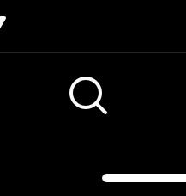 **This is the search button users need to click**

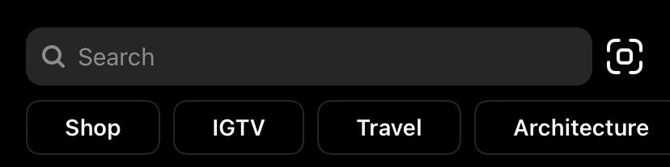

**This the search bar that users need to use**

* An error that a user might make from completing this task is when the user makes a typo in the search bar. Users can also lose the internet while searching. Instagram server could have crashed in the process.

Task2:

* Direct messaging friends
* To direct message friends, users need to click on the icon on the top right of the screen. Once clicked, it will redirect to another display where you can see all of your friends or other instagram accounts you have talked to before. In order to talk to a specific friend, you need to click on their name and it will then again redirect to another display. If you want to send them a message, all you need to do is type in the message into the input box on the bottom of the screen. Then, hit the send button on your keyboard.

 **This is the message icon**

* An error that might prevent a user from completing this task is when they don’t have any cellular or wifi service. Instagram requires the users to have either of those two to function. The app could crash for unexpectedly.

Task3

* Look at top trending posts
* To look at top trending posts, all the users have to do is click on the search button and the app will redirect to the top trending posts display. Users do not need to fill in any input fields to look at the top trending posts. Whenever users refresh the page, the app will update the top trending posts.

 **Users need to click on this to look at top trending posts**

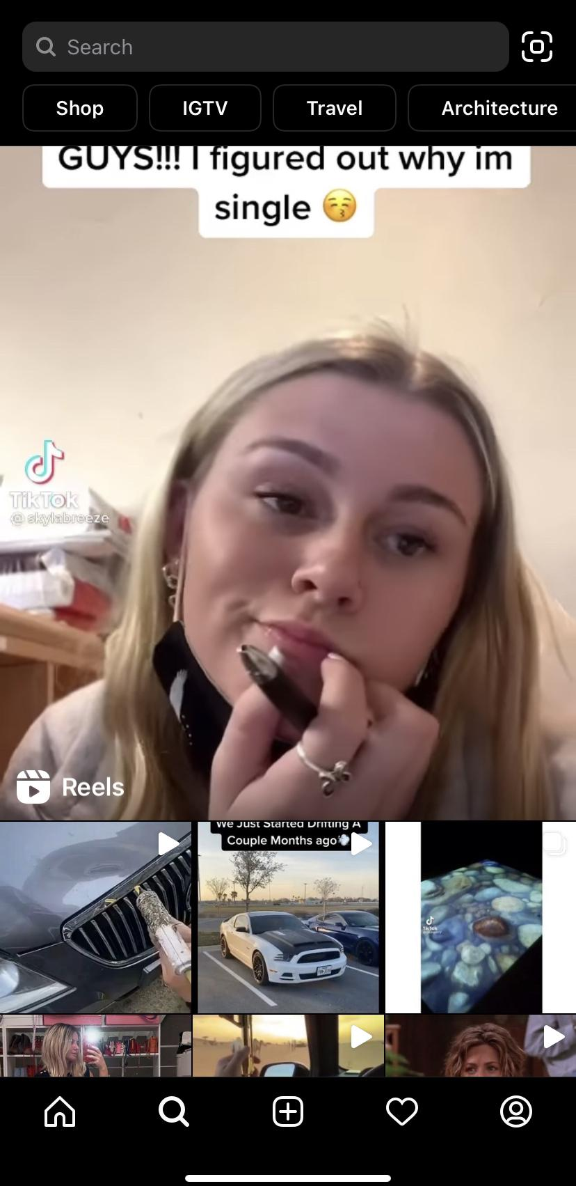 **This is the top trending posts display**

* An error that might prevent a user from completing this task is when they don’t have any cellular or wifi service. Instagram requires the users to have either of those two to function. Your account could get banned and you lose the privilege to use their services.